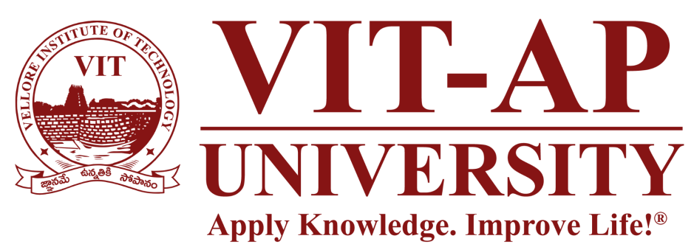

Second Review

Project Title:-
SkyWrite In The Wind Using Python And OpenCv

Course: Summer Internship Project (22 Batch MTCSE & MTSE) Presented by: 1) G. Thulasidhar Reddy [Reg. No. 22MIC7099]
2) V. Jaya Chandra [Reg. No. 22MIC7215]
3) K. Vishwesh Aryan [Reg. No. 22MIC7109]
Project Guide:Prof: A. Padma

Project Summary

This project has successfully created a fully functional "Air Canvas" application. It allows users to draw on a virtual screen using hand gestures captured by a webcam, effectively translating real-world motion into digital art. The system accurately tracks the user's fingertip and includes a professional UI with multiple colors, brush sizes, and advanced drawing tools. This project serves as a strong proof-of-concept for more intuitive and natural forms of human-computer interaction.

Detailed Implementation

All core objectives have been met, and several advanced features have been implemented.
- Professional UI: The basic UI has been upgraded to a professional-looking interface. It features semi-transparent overlays and logically grouped toolbars for colors, drawing modes, and brush thickness, creating a better user experience.
- Advanced Shape Tools: The application's capabilities have been expanded beyond free-form drawing. It now supports drawing perfect geometric shapes, including:
  - Rectangles
  - Circles
  - Lines
  - Ellipses
- Save Functionality: A "Save" button has been successfully implemented. Users can now save their finished artwork as a PNG image file. Each file is automatically named with a timestamp to prevent overwriting previous drawings.
- Live Pointer on Canvas: To improve precision, a live cursor has been added to the "Paint" window. This pointer tracks the fingertip's position on the canvas at all times, giving the user exact feedback on where their next mark will be.

Results and Discussion

- First we'll build a working system that lets you draw on a screen in real-time just by moving your hand.
- We're going to use a standard, off-the-shelf webcam, so the system is accessible to anyone without needing special hardware.
- A key part of the project is implementing high-accuracy hand and fingertip detection using the Mediapipe library. This will give us the precise coordinates we need for drawing.
- We'll use OpenCV to handle all the visual processing—capturing the video, drawing the user's path, and displaying the final canvas.
- Finally, we'll build a simple user interface so you can easily switch between colors or clear the screen.

Conclusion and Future Scope

The "SkyWrite" project has successfully achieved its goal of creating a gesture-controlled virtual canvas. By combining Python, OpenCV, and Mediapipe, we have built a powerful yet accessible tool for air writing that moves beyond traditional input devices.
- Future Scope:
  - AI Character Recognition: An "Auto-Write" feature that uses a machine learning model to recognize hand-drawn letters and numbers could be implemented and refined.
  - More Advanced Tools: Professional features like a "fill" tool, different brush textures, and a layering system could be added.
  - 3D Drawing: For a truly next-generation experience, the project could be re-imagined using a 3D rendering engine like OpenGL, allowing users to create art in a virtual 3D space

THANKYOU.

